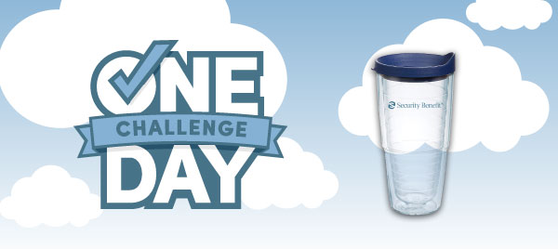
Thank you for meeting
With me to plan for your
One Day.

Aligning your retirement plans with your retirement savings is a pivotal step in planning for your future. While it’s hard to believe, retirement and pension comes quickly, and you need to be ready when it gets here. Now you’re one step closer to the future of your dreams.

To celebrate, get your free travel mug.
Visit securitybenefit.com/ThankYou to have it mailed directly to you.

Thank you again for your time today to plan for tomorrow.


SB-10010-69 | 2023/01/23

Neither Security Benefit Corporation nor its affiliates are fiduciaries. This information is general in nature and intended for use with the general public. For additional information, including any specific advice or recommendations, please visit with your financial professional.



