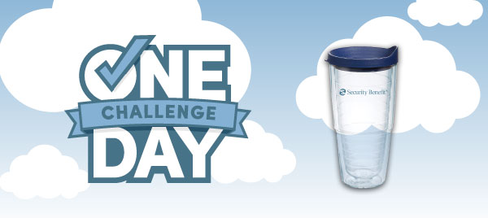
We all dream of One Day.

One Day I’ll visit the Grand Canyon.
One Day I’ll own a cabin by the lake.
One Day I’ll open a bookstore of my own.

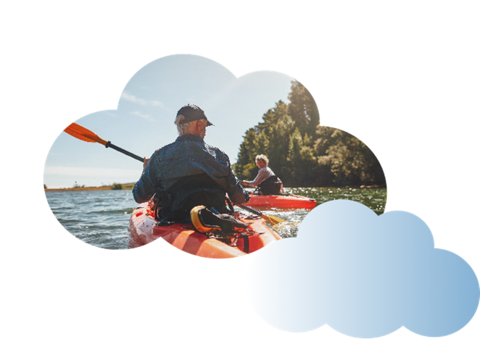
But if your retirement plans don’t align with your retirement savings and pension, making One Day possible can be tough.

I invite you to participate in the One Day Challenge and review your retirement savings and pension. Whether you’ve just started, or you’re one year away from retirement, the One Day Challenge can help make your future dreams a reality. Small steps like meeting a financial professional or increasing your contributions to your 403(b), can make a big difference down the road. Together, we’ll align your assets with your retirement aspirations to start your path to One Day.


Take the
One Day Challenge
and receive your
free travel mug.

SB-10010-68 | 2022/12/27

Neither Security Benefit Corporation nor its affiliates are fiduciaries. This information is general in nature and intended for use with the general public. For additional information, including any specific advice or recommendations, please visit with your financial professional.



